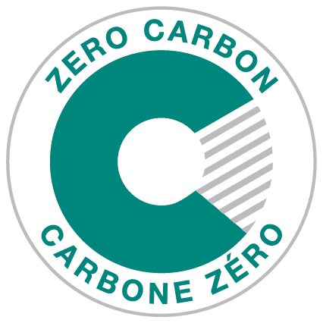

Zero Carbon Building Version 3
Embodied Carbon Reporting Template
June 20, 2022
1. INTRODUCTION 3
2. GENERAL INFORMATION 4
3. CARBON EMISSIONS FOR EACH LIFE CYCLE STAGE 5
3.1 Contribution Analysis 6
4. IMPACT AND INNOVATION 7
4.1 Impact and Innovation - Percent Reduction in Embodied Carbon 7
4.2 Impact and Innovation - Net Upfront Carbon Emissions Equal to or Less Than Zero 9

1. INTRODUCTION
The purpose of this reporting template is to outline the information that is required to be submitted in the embodied carbon report that is required for ZCB-Design v3 certification. Projects may complete this template or provide a custom report that meets the information needs specified herein.
Projects pursuing ZCB-Performance v2 certification that complete a retrofit of structural or envelope materials in the performance year must also use this template to guide the reporting of embodied carbon associated with the retrofit project. Alternatively, they may use the version of this template that was released with ZCB-Performance v2, as this updated template does not include any changes that are relevant to ZCB-Performance v2 projects.

2. GENERAL INFORMATION
Please provide the following general information about the project.
Project Name
Embodied Carbon Assessor
Firm
Date of Assessment Completion
Software & Version Number
Project Life | ☐ 60 year
Assessment Timing  (check all that apply) | ☐ Schematic Design  ☐ Design Development  ☐ Construction Documents
Please confirm that the analysis includes all structural and envelope components (“mandatory materials”) by checking the applicable boxes to the right. | ☐ Footings and foundations  ☐ Complete structural wall assemblies (cladding to finish)  ☐ Structural floors and ceilings (no finishes)  ☐ Slab on grade  ☐ Roof assemblies  ☐ Stairs  ☐ Parking structure (not including surface parking)
Please list any additional materials that are included at the applicant’s discretion.

3. CARBON EMISSIONS FOR EACH LIFE CYCLE STAGE
Provide the following breakdown by life cycle stage. If the software used does not provide values for every stage, leave the missing ones blank.
Life Cycle Stage |  |  |  | Carbon Emissions from Mandatory Materials  (kg CO₂e) | Carbon Emissions from Optional Materials  (kg CO₂e)
Upfront | Product | A1 | Raw Material Supply
 |  | A2 | Transport (to factory)
 |  | A3 | Manufacturing
 | Construction | A4 | Transport (to site)
 |  | A5 | Construction & Installation
 |  |  | Total Upfront Carbon
Use |  | B1 | Use
 |  | B2 | Maintenance
 |  | B3 | Repair
 |  | B4 | Replacement
 |  | B5 | Refurbishment
 |  |  | Total Use Stage Embodied Carbon
End of Life |  | C1 | Demolition
 |  | C2 | Transport (to disposal)
 |  | C3 | Waste Processing
 |  | C4 | Disposal
 |  |  | Total End of Life Carbon
Optional, does not need to be offset:
Beyond  the Life Cycle |  | D | Reuse
 |  | D | Recycling
 |  | D | Energy Recovery
 |  |  | Total Beyond the Life Cycle Carbon

3.1 Contribution Analysis
Please provide a contribution analysis, broken out to the best of your ability by either material type or building assembly type. The list must include the top 10 contributing items at a minimum (concrete can only count as one, although multiple mix types can be listed separately).
Material or Building Assembly | Carbon Emissions  (kg CO₂e)

4. IMPACT AND INNOVATION

4.1 Impact and Innovation - Percent Reduction in Embodied Carbon
ZCB-Design projects pursuing Impact and Innovation strategies for demonstrating an embodied carbon reduction of 20% or 40% must provide the following information. Projects pursuing Impact and Innovation using an absolute embodied carbon reduction do not need to complete this section.
Please provide a summary description of the embodied carbon reduction measures that were implemented.

Please explain how the baseline building and the proposed building have equivalent operational energy use, floor area, functional space use, and building shape/orientation.

Please provide a summary of the embodied carbon reductions achieved.
Life Cycle Stage |  |  |  | Baseline  (kg CO₂e) | Proposed  (kg CO₂e) | Percent Reduction
Upfront | Product | A1 | Raw Material Supply
 |  | A2 | Transport (to factory)
 |  | A3 | Manufacturing
 | Construction | A4 | Transport (to site)
 |  | A5 | Construction & Installation
 |  |  | Total Upfront Carbon
Use |  | B1 | Use
 |  | B2 | Maintenance
 |  | B3 | Repair
 |  | B4 | Replacement
 |  | B5 | Refurbishment
 |  |  | Total Use Stage Embodied Carbon
End of Life |  | C1 | Demolition
 |  | C2 | Transport (to disposal)
 |  | C3 | Waste Processing
 |  | C4 | Disposal
 |  |  | Total End of Life Carbon

4.2 Impact and Innovation - Net Upfront Carbon Emissions Equal to or Less Than Zero
ZCB-Design projects pursuing the Impact and Innovation strategy of demonstrating upfront carbon emissions equal to or less than zero must provide the following information.
Please provide a description of any strategies for biogenic carbon storage (sequestration) in the building materials and provide the associated reduction in upfront carbon emissions (life cycle stages A1-A5).
Description of Carbon Storing Material | Amount of Material  (kg) | Biogenic Carbon Storage  (kg CO₂e)

Please provide the upfront carbon demonstrating it is less than or equal to zero.
Upfront Carbon  (kg CO₂e) | Total Biogenic Carbon Storage  (kg CO₂e) | Net Upfront Carbon  (kg CO₂e)

